Biotechnology Spring Performance Review—KEY
- 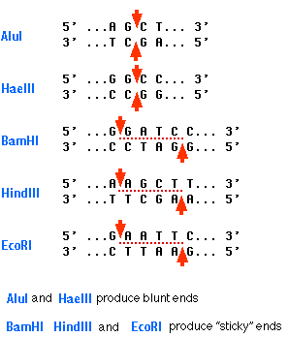
- 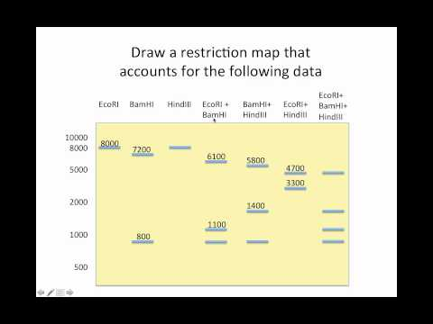 The left column shows the base pair length. Undigested shows a big “clump” at the top; no individuals bands
- Enzymes; protein catalysts which mostly end with –ase
- Pectinase
- 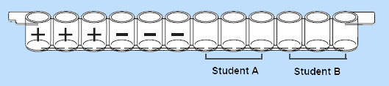
- 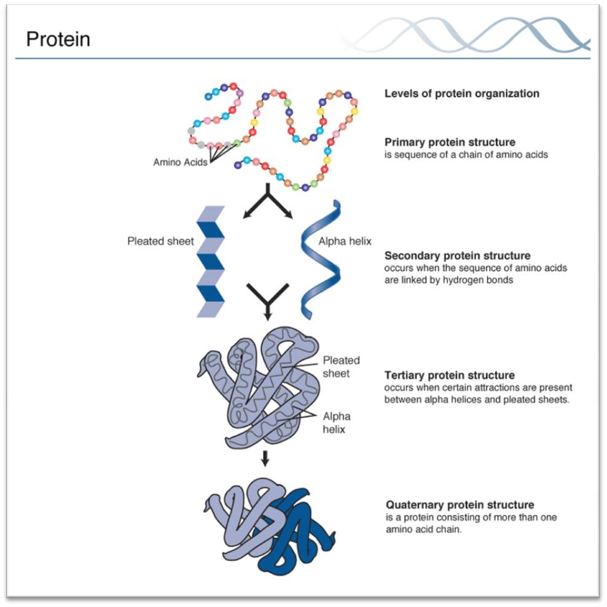
- Protein—TRIS buffer Agarose—TAE buffer
- Polyacrylamide gels
- Amino acids
- 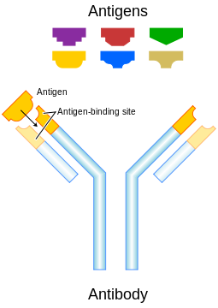
- Denaturation—melts the two strands of DNA
Annealing—oligonucleotides prime their complimentary base pairs
Extension—adds nucleotides one at a time
- 1st Denaturation, 2nd Annealing, 3rd Extension
- Define using notes, google, online dictionary, etc. For acronyms, be able to tell what the letters stand for in the acronym name.

