Microorganism Test Review Name ___________________________

1. What is the common staining technique used to identify bacteria and what colors are positive and negative?

2. What is a bacteriophage?

3. Name all the parts of a virus.

4. What happens in the Lysogenic cycle of a virus? (Include Provirus)

5. What are the events of the Lytic cycle?

6. Why is a virus not considered alive?

7. How do bacteria reproduce sexually and asexually?

8. What domain contains bacteria?

9. What treatment can be used to treat a bacterial infection?

10. What treatment can be used to prevent a viral infection?

11. A retrovirus contains which nucleic acid? ___________ Name 2 retroviruses and tell why they are so dangerous?

12. Label the following prokaryote cell:
1.
2.
3.
4.
5.
6.
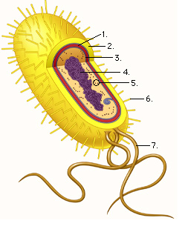
7.

13. List the shapes and groupings common to Eubacteria:

14. How can you prevent food from spoiling?

15. Fungi and ________________ are primary decomposers.

16. Some bacteria are capable of nitrogen fixation. Define this process.

17. Draw and label the following protists: Amoeba (how does an Amoeba move?) , Paramecium (what is the function of a contractile vacuole?)and Euglena (what is special about the Euglena?)

18. What is another name for animal like protists? Plant like ?

19. Name the three groups of K. Archaebacteria.

20. What is the difference between photoautotrophs and chemoautotrophs?

21. Is HIV due to lytic or lysogenic infection?

22. Viruses that contain RNA are known as____________________________________________.

23. How do antibiotics kill bacteria?

24. Archaebacteria are found in very ______________________________________environments.

25. What characteristic is common to ALL protists?

27. To what domain do protists belong?

28. Protists may be ______________________like, ____________________like, or __________________like.

29. Name two examples of fungus-like protists.

30. How are animal-like protists classified? Plant-like?

31. How do Euglena move?

32. Name the protist that causes African sleeping sickness.

33. Name the protist that does not move and causes Malaria.

