Performance Final Exam Review Sheet: 2013 Performance Final Exam December 6, 2013
- What is the total length of the two segments in drawn below in:
- _____mm and B. ___cm?
____20 mm______ = 2 cm __________4.5 cm______________ = 45 mm

- Read the thermometer and the graduated cylinder below.
What is the temperature of the thermometer? ___75.5___°C
What is the reading in mL of the graduated cylinder? _46.0____mL
What is the bottom curve on the graduated cylinder called? ___meniscus__________________
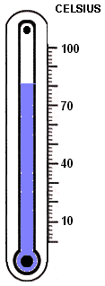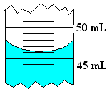
Thermometer Graduated Cylinder
- A high school biology student is conducting a controlled experiment. She wants to see the effects of fertilizer on plant growth. Her hypothesis is the following: The plant that does not receive fertilizer will grow less than the plant that receives fertilizer. In conducting her experiment, all factors are the same except the fertilizer.

What is the independent (manipulated) variable? ___fertilizer__________

What is the dependent (responding) variable? _____plant growth___________

What would some constants be in this experiment? ____type of plant, amount of water, type of soil, size of pot, amount of light, intensity of light__

- Convert the following using the metric system:
1.3 m to __130___ cm .3g to ___300____ mg 40 kg to ____40,000___g

- What are the steps of the scientific method: State the Problem, Hypothesis, Set up a Controlled Experiment, Gather and Analyze Data, Conclusion
- What is measured in Liters? _____liquid volume____________
- What is measured in Meters? ______length____________
- What is measured in Grams? ______mass____________
- What is Qualitative Data? ___________descriptive data/adjectives____________________________
- Give examples of qualitative data: __color, odor, texture, behavior, shape______
- What is Quantitative Data? _____numerical data_
- Give examples of quantitative data? ____ percentages, averages, numbers, frequency, measurements
- What is an observation? _____data collected using five senses—basically facts/details_
- What is an Inference? _______drawing a conclusion based on prior knowledge(“connecting the dots”)__
- Give an example of each in #13 and #14:
Observation: My dog is white with a black dot. The dog has a pink collar. The dog’s ears are brown.
Inference: Pink must be the dog owner’s favorite color. The dog is often dirty because it is white.
- Complete the graphing practice problem and answer the questions below:
Graphing Practice Problem
pH of water  X-axis | Number of tadpoles  Y-axis
8.0 | 45
7.5 | 69
7.0 | 78
6.5 | 88
6.0 | 43
5.5 | 23
- Make a line graph of the data.
- What is the dependent variable? __________number of tadpoles_____________________________
- What is the independent variable? _________pH of water__________________________________
- What is the average pH in this experiment? _______6.75 (6.8)______________________________
- What is the average number of tadpoles per sample? ___57.7(58)____________________________________
- What is the optimum water pH for tadpole development? ____6.5__________________________________
- Between what two pH readings is there the greatest change in tadpole number? __6.0-6.5______________
- How many tadpoles would we expect to find in water with a pH reading of 5.0? ___<23_________________
- A clam farmer has been keeping records concerning the water temperature and the number of clams developing from fertilized eggs. The data is in the chart below:
Degrees Celsuis | # of Developing Clams
15°C | 75 clams
20°C | 120 clams
25°C | 120 clams
30°C | 140 clams
35°C | 60 clams
40°C | 40 clams
45°C | 0 clams
Using the data table above, answer the following questions:
  - What is the best temperature to produce the most developing clams? ____30°C ___________
  - What is the worst temperature to produce the most developing clams? ___45°C ___________
  - At what temperature, was the same number of clams produced? ____20-25°C _______________
  - How many temperatures were observed? ____7___________
  - How many clams were produced at 15, 20, 25 and 30°C? ______455____________________
- Use the climatogram to answer the questions below.
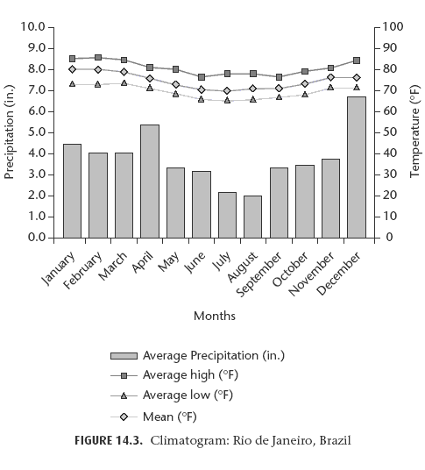
- Examine the climatogram of Rio de Janeiro, Brazil.
- On the left side of the graph, find the precipitation scale.
- On the right side of the graph, find the temperature scale.
- Locate the months along the x-axis.

Follow-Up Questions
- What is Rio de Janeiro's rainiest month? December What is its driest month? August
- Judging by the mean temperature, what is Rio de Janeiro's coolest month? July What is its warmest month? January
- In your opinion, what would be the best month to vacation in this locale? Explain your reasoning.

