Unit 4---CELLS STRUCTURE AND MOVEMENT

The Cell Theory
- The first lenses were developed in Europe in the late 1500’s by merchants needing to determine the quality of cloth.
- In Holland in the early 1600’s, two useful instruments were constructed: the telescope and the microscope.
- In the 1600’s Anton van ____________________________________________________________________________ to study nature.
- His simple microscope enabled him to see things that no one had ever seen before.
- In 1665, English physicist ______________________________________used on of the first light microscopes to look at thin slices of plant tissues.
- Cork caught his eye because it seemed to be made of thousands of _________________________________
____________________________________________________________.
- Cells are the basic units of all forms of life.
- In 1838, German botanist _________________________________________concluded that all _______________
___________________________________________________________________________________________________
- The next year, another German scientist, _______________________________________, concluded that all
___________________________________________________________________________________________________
- ____________________________________determined ___________________________________________________
_____________________________________________________________________
- These discoveries are summarized in the Cell Theory, one of the fundamental concepts of Biology.
- The Cell Theory states the Following:
- 1. _________________________________________________________________________________________
- 2. _________________________________________________________________________________________ 3. _________________________________________________________________________________________

Basic Cell Structures…
- Cells can range in size from 0.2 micrometers (tiny bacteria) to 1000 micrometers (giant amebas).
- All cells have a_______________________________________________.
  - The Cell Membrane is a thin, flexible barrier around the cell.
- Many cells also have a strong layer around the cell membrane known as the _________________________.
  - Cell Membranes and Cell Walls ______________________________________________________________ cells, while allowing them to interact with their surroundings.
- Some cells contain a______________________________.
  - The _______________________is a large structure that contains the cell’s genetic material and controls the cell’s activities.
- The Cytoplasm __________________________________________________________________________________, not including the nucleus.

Prokaryotes and Eukaryotes
- Biologists divide cells into two categories: eukaryotes and prokaryotes.
- Eukaryotes ________________________________a nucleus.
- Prokaryotes _______________________________have a nucleus.

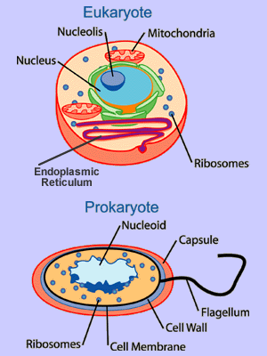

Draw and label a bacterial prokaryote
Prokaryotes
- The cells of prokaryotes are generally smaller and simpler than the cells of eukaryotes.
- _____________________________have cell membranes and cytoplasm but______________________________ _________________________________________.
- ALL _________________________________are prokaryotes.
- Ex: E. coli and Staphylococcus aureus.
- Prokaryotes grow, reproduce and respond to changes in the environment.

Eukaryote: on notebook paper draw a eukaryotic animal cell.
- Unlike the cells of prokaryotes, the cells of _______________________do contain a_____________________.
- In addition to a nucleus, a cell membrane and cytoplasm, most cells of eukaryotes contain dozens of other specialized structures, called_____________________________.
- Organelles are specialized structures that perform important cellular functions.
- Although some eukaryotes live solitary live as single-celled organisms, many are large multicellular organisms.
- All ___________________________________________________________________________________are eukaryotes, as well as many microorganisms.

Cell Structures
- ___________________________________l
- Cell walls are found in many organisms, including plants, algae, fungi and nearly all prokaryotes.
- The________________________________________________________________________________________________.
- Most cell walls allow water, oxygen, carbon dioxide, and other substances to pass through them.
- The main function of the Cell Wall is to_______________________________________________________________.
- Most cell walls are made from fibers of carbohydrate and protein.
- Plant cell walls are made mostly of_____________________________, a tough carbohydrate fiber.
- Cellulose Is the principal component of both wood and paper.

- Nucleus
- The Scottish botanist Robert Brown first identified the nucleus in 1831.
- The Nucleus ________________________most cell processes and contains the ___________________________ ____________________________________________________________________________(deoxyribonucleic acid).
- Almost ALL eukaryotic cells contain a nucleus including plant and animal cells.
- ___________________holds the coded instructions for making proteins and other important molecules.

- Chromatin and Chromosomes
- The granular material visible within the nucleus is called_______________________________.
- It consists of______________________________________________________________________________.
- Most of the time, chromatin is spread throughout the nucleus.
- When a cell divides, chromatin condenses to form __________________________________________________.
- ________________________________________________________________________________________________________________________________________________________________________________________________________.

- Nucleolus
- The _____________________________ is the location inside the nucleus where the _________________________ _____ ________________ begins.
- Ribosomes aid in the production of __________________________in the cell.

- Nuclear Envelope
- The nucleus is surrounded by a double-membrane layer called the Nuclear Envelope.
- The Nuclear Envelope is dotted with thousands of _________________________________________which allow materials to move__________________________________________________________________________________.
- The nucleus sends a steady stream of RNA and other information-carrying molecules to the rest of the cell through the nuclear pores.

- Cytoskeleton
- The ____________________________is also involved in many forms of cell movement.
- The cytoskeleton is made of microtubules and microfilaments.
- ________________________________maintain cell shape and can also serve as “tracks” along which organelles are moved.
- In some cells, bundles of microtubules form hair-like projections from the cell surface known as cilia and flagella that enable the cell to swim rapidly through liquids.
- _____________________________are long, thin fibers that function in the movement and support of the cell.

- Ribosomes
- ___________________________________________________________________________________________________.
- Proteins are assembled on__________________________________.
- Ribosomes produce proteins following coded instructions that come from the nucleus.

- Endoplasmic Reticulum
- Found in___________________________________________.
- The Endoplasmic Reticulum is the organelle in which components of the cell membrane are assembled and some proteins are modified.
- The part of the endoplasmic reticulum involved in protein synthesis is the Rough Endoplasmic Reticulum.
- Newly made proteins move directly from the ribosomes to the Rough Endoplasmic Reticulum.
- The smooth endoplasmic reticulum__________________________________________________________________.
- The smooth endoplasmic reticulum contains collections of enzymes that perform specialized tasks such as the synthesis of lipids.
- Rough Endoplasmic Reticulum _______________________________________________________________.

- ______________________Apparatus
- A stack of membranes.
- _______________________________in the Golgi Apparatus attach carbohydrates and lipids to proteins.
- From the Golgi apparatus, ______________________________are sent to their final destination.
- __________________________________________________________________________of materials. THINK UPS

- Lysosomes
- Lysosomes are small organelles___________________________________________________________________.
- One function of the Lysosomes is to ______________________________________________________________ _____________________________________from food into particles that can be used by the rest of the cell.
- Lysosomes also help break down organelles that have outlived their usefulness.
- Lysosomes help keep the cell clean from debris.

- Vacuoles
- Cells often __________________________________such as water, fats, proteins, and carbohydrates in saclike structures known as vacuoles.
- Many plant cells have a single large, ____________________________________________ filled with liquid, as makes it possible for plants to support heavy structures such as leaves and flowers.
- Vacuoles are also found in single-celled organisms and animal cells.
- Smaller vacuoles are typically called_________________________________.

- Chloroplasts
- The _____________________________________________________________________and some other organisms.
- _________________________________________________________________________DO NOT have chloroplasts.
- Chloroplasts ______________________________________________________________________to make energy-rich food molecules in a process known as_________________________________________.
- The green pigment ____________________________________is located in the photosynthetic membranes surrounding the chloroplasts.

- Mitochondria
- The __________________________________________________--are organelles that______________________________________________________________________________________________.
- Mitochondria use the energy from food to make high-energy compounds that the cell can use to power growth, development and movement.
- The Mitochondria are the _______________________________________________________________________ .
- Mitochondria are enclosed by two envelope membranes, an out and inner membrane.
- Mitochondria are found in nearly all eukaryotic cells.

14. Centrioles
  - They aid in reproduction of the cell in animal cells.

Organelle DNA
- Unlike other organelles, chloroplasts and mitochondria contain some of their own genetic information in the form of DNA.
- The small DNA molecules contain information that is essential for the normal function of both organelles.
- Mitochondrial DNA, as believed by many, is just the remnant of the genetic information of the bacteria from which mitochondria are descended.
- In humans, all or nearly all of our mitochondria come from the cytoplasm of the ovum, or egg cell.
- This means that when your relatives are discussing which side of the family should take credit for your best characteristics, you can tell them that you got your mitochondria from MOM.

Comparing Cells
Structure | Prokaryotic Cells | Eukaryotic (Animal) | Eukaryotic (Plant)
Cell Membrane
Cell Wall
Nucleus
Ribosomes
Endoplasmic Reticulum
Golgi Apparatus
Lysosomes
Vacuoles
Mitochondria
Chloroplasts
Cytoskeleton

7-3: Movement Cell Membrane
- The_______________________________________________________________________________________________ __________________________________________________________________.
  - The cell takes in food and water and eliminates wastes through the cell membrane.
- The core of nearly all cell membranes is a double-layered sheet______________________________________.
  - Lipid bilayers form by themselves when certain kids of lipids are dissolved in water.
  - The Bilayer gives cells a tough, flexible structure that forms a strong barrier between the cell and its surroundings.
- Most cell membranes ________________________________________________________________________that run through the lipid Bilayer.
  - Carbohydrate molecules form chains that are attached to the outer surfaces of these proteins.
  - Some of the proteins help form channels and pumps that help to move material across the cell membrane.
- Many of the carbohydrates act like chemical identification cards, allowing cells to identify
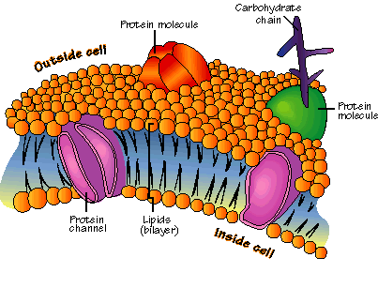
Phospholipid Molecule
Makes up the lipid bilayer.
Made of a polar head, phosphate group, and 2 fatty acid tails. Polar heads are on the outside of the bilayer (hydrophillic). Fatty acid tail face inward of the bilayer (hydrophobic).

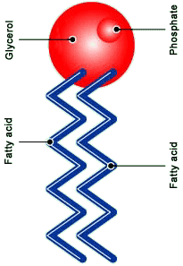
Diffusion
- Every living cell contains a liquid interior and is surrounded by liquid.
- The cell membrane _______________________________________________________________________________ from the solution within the cell.
- One of the most important jobs of the cell membrane is to regulate what enters and exits the cell.
- In a solution, molecules are in constant motion.
- Because of movement and collisions, molecules tend to move from _________________________________ concentration ______________________________concentration.
- Diffusion is defined as the __________________________________________________________________________
___________________________________________________________________________________________________
- Diffusion causes many substances to move across a cell membrane but does not ____________________
___________________________________________________________.
- Suppose two substances are present in unequal concentration on either side of a membrane. The substance that can cross the membrane will tend to move toward the area where it is less concentrated until equilibrium is reached.
- At this point, the concentration on each side of the membrane will be____________________.

Osmosis
- Not all substances cross biological membranes.
- If a substance can pass through a membrane, the membrane is_____________________________.
- Most biological membranes are_________________________________________________________, meaning that ______________________________________________________________________ across them and others cannot.
- A process called Osmosis allows water molecules to pass easily through most biological membranes.
- _____________________________is the diffusion of ___________________through a selectively permeable membrane.
How Osmosis Works
- Ex: Sugar in solution outside of a membrane.
  - Water is more concentrated outside the membrane because of the sugar.
  - Water will diffuse into the cell until the concentration of water and sugar are equal.
- ______________________________means the two solutions are equal.
- ______________________________means more concentrated.
- ______________________________means less concentrated

Osmotic Pressure
- Osmosis exerts a pressure known as osmotic pressure on the hypertonic side of a selectively permeable membrane.
- Osmotic pressure should typically produce a ________________________________of water into a typical cell that is surrounded by fresh water.
- This causes a cell to ______________________.
- Most cells however exist in isotonic solutions and do not need to worry about swelling.
- Cell walls in plants prevent osmotic pressure from destroying plant cells.

Osmotic Pressure

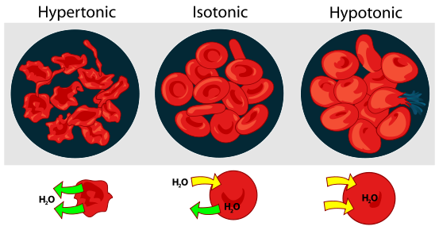

Facilitated Diffusion
- Some molecules, including alcohol, water and small lipids, can move through the lipid Bilayer and diffuse directly across the cell membrane.
- Other molecules cannot cross the lipid Bilayer but do diffuse across the membrane.
- Many membranes have protein channels that allow molecules to cross the membrane.
- These protein channels are specific to molecules and help Facilitate the diffusion of the molecule.
  - Ex: Glucose in red blood cells.
- Diffusion that occurs with these______________________________________________________________________.

Active Transport
- Often materials need to move from an area of lower concentration to an area of higher concentration.
- ________________________________________________________________________________________________________________________________________________________________________________________________________.
- Active transport of small molecules is often compared to a pump.
  - Ex: animal cells pump sodium ions out of a cell and potassium ions in.
  - There is typically a high concentration of potassium but a low concentration of sodium.

- In_________________________________, large amounts of material are taken into the cell by means of infolding, or pockets, formed by the cell membrane, then transformed into vacuoles.
- When large molecules are taken into the cell and stored that is called________________________________.
- The removal of large amounts of material from a cell is known as______________________________________.
- During exocytosis, the membrane of the vacuole surrounding the material fuses with the cell membrane, forcing the contents out of the cell.

Unicellular Organisms
- _______________________are the basic living units of all organisms, but sometimes a single cell is a little more than that.
- Sometimes a cell IS the organisms.
- Unicellular organisms do everything that you would expect a living thing to do.
- They grow, respond to the environment, and reproduce.
- Unicellular organisms include both prokaryotes and eukaryotes.
- Prokaryotes, especially bacteria, are highly adaptable and can live almost anywhere.
- Many eukaryotes such as algae and yeast are also widespread.
- Some unicellular species are solitary, some colonial.

Multicellular Organisms
- The cells of multicellular organisms do not live on their own.
- They are_________________________________________________________________________________________ _______________________________________________________________________.
- Multicellular organisms have Cell Specialization, or separate roles for cells.
- Cells in multicellular organisms are specialized to perform particular functions within the organism.
- Ex: pancreatic cells, heart cells, skin cells, stomach cell.

Levels of Organization
- The levels of organization in a multicellular organism are individual_____________________________, tissues, organs, ____________________________________________________________________________________________.
- Cells are the basic unit of structure and function for all living things.
  - There are many different types of cells such as nerve cells, cardiac cells, skin cells etc…
- A Tissue is a group of similar cells performing the same function.
  - Ex: cardiac cells compose cardiac tissue.
- When many groups of tissues work together they form an organ.
  - Ex: Cardiac tissue makes the heart.
- When a group of organs work together to perform a given task they are an organ system.
  - Ex: the circulatory system.

